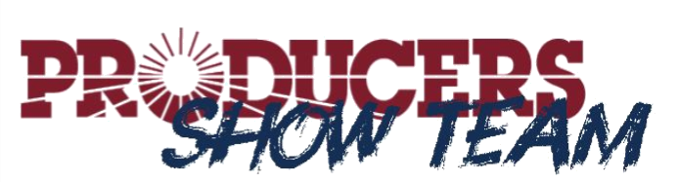

Show Team Information and Registration
How do I register?
- Fill out the registration form on our website:
https://www.producerscooperative.com/show-team/#
OR
- Contact Ashley Carraway at acarraway@producerscooperative.com by calling 979-778-6000 extension 232.
When do I register?
- Each exhibitor needs to register annually.
- Registration needs to take place in a considerable amount of time before your show season begins.
Show Team Eligibility
Youth showmen who exhibit any of the following species at the county, state or national level are eligible.
Breeding: Market:
- Heifers - Steers - Commercial Steers or Heifers
- Gilts - Swine - Turkeys
- Ewes - Lambs - Broilers
- Does - Goats - Rabbits

Qualifying for Awards
- County Shows:
Must win Overall Grand or Reserve Grand Champion in a market show.
Breeding classes are not eligible at the county level.
- Major Shows:
(Ft. Worth, Houston, Austin, San Antonio, San Angelo, State Fair, Denver, Louisville, Kansas City or State and National Breed Association Shows)
Must win Overall Grand or Reserve Grand Champion in a market or breeding show.
OR
Must win Grand or Reserve Champion of their breed in a market or breeding show.
Division and class winners are not eligible.
- Prospect, Local FFA/4-H and jackpot shows are excluded.

Verifying Your Winnings!
CHECKLIST:
- Exhibitors must notify Producers within 60 days of their winning by contacting Ashley Carraway or through the show team verification form on our website.
- Copies of your feed purchase receipts will be requested.
If you are a member, we can search your purchase history.
Non-members can create a tracking account to track your purchases. Just ask us!
Number of receipts needed per species:
Show Cattle Feeds – 20 proofs of purchase
Show Pig Feeds – 9 proofs of purchase
Show Goat Feeds – 9 proofs of purchase
Show Lamb Feeds – 9 proofs of purchase
Show Turkey/Broiler Feeds – 6 proofs of purchase
Premium Rabbit Pellet – 3 proofs of purchase
- A digital photograph will need to be included, as well.
The photograph must include the exhibitor, the animal, the trophy/banner and the official sign/logo of the show attended.
The photograph needs to be in “JPEG” format.
The photograph will be posted on our social media sites to celebrate your success! If you are not okay with being presented on our social media sites, please let us know.

**** Notifying PRODUCERS of your winnings, along with sending a photograph gives PRODUCERS COOPERATIVE ASSOCIATION your parent or guardian’s permission to use your photograph and your information on our website, print collateral, promotional materials, and all forms of television and radio communications for the purpose of promoting youth in agriculture.

